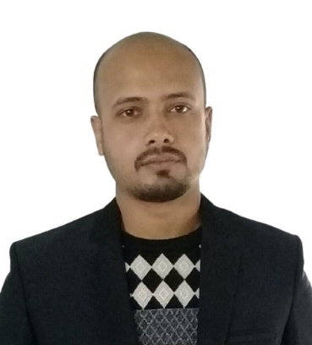

**Md Kabirul Islam**

**Electrical & Electronics Engineer**

**Achieve higher career growth through a continuous learning process and keep myself dynamic, visionary and competitive with the changing scenario.**

CAREER OBJECTIVE

WORK EXPERIENCE

|  |  |
| --- | --- |
| **YAMAHA MOTORCYCLES**  **(ACI MOTORS BANGLADESH)**  Jan’20- Present | **Junior Engineer(Production & Quality)**  Achieving daily production target both Weld shop & Paint shop, Achieving productions LSPR & GSPR, Pre-treatment Parameter Control, Inspection the process flow and machine parameters both weld shop & paint shop, Monitoring the operation for defect free products, Verified & judgement welding penetration test, Maintain Paint Quality Parameter, Create standard Quality Engineering Documents, Consult with production operators for defect free products, Operate Co-ordinate Measuring Machine and assist in-charge for any measurement, Reporting the problem with root cause analysis, Train new employees on inspection and repair procedure with operation standard, Prepare daily quality report, Strictly adhere to the YAMAHA Standard if not being followed immediately report to the reporting boss. |
|  |  |
|  |  |

CONTACT

Barachala, Rajabari., Sreepur, Gazipur,

+8801906687488

Kabirul Islam

fxkabir@yahoo.com



Speaker Phone





ACHIEVEMENTS

* **I got a maximum of CGPA (3.94) from our university.**
* **Got semester wise webinars for good academic performance.**

**EDUCATION**

INTERESTS

* Photography
* Music
* Travel
* Sports
* Interior Design
* Reading

|  |  |
| --- | --- |
| B.Sc. in Electrical & Electronics Engineering. (2019) | **North Western University, Khulna.**  **CGPA 3.94** |
| Diploma in Electrical Engineering (2013) | **Khulna Polytechnic Institute, Khulna**  **CGPA 3.74** |
| Secondary School Certificate (2009) | **Parulia S.S High School.**  **Group: Science**  **GPA – 5.00** |

COMPUTER SKILLS

* Proficiency in Microsoft Office
* Solid Works
* Graphics Design
* Professional Video Editor.

**LANGUAGE SKILLS**

Proficiency with reading, writing and speaking of both English and Bengals.

**CERTIFICATION**

CCNA Routing & Switching Routing & Switching (Version 6.00) Khulna University of Engineering and Technology (**KUET**)

INDUSTRIAL VISIT

* Mongla Cement Factory
* Power Grid Company of Bangladesh (PGCB)
* **Installation and setup of routers and switches**
* **Troubleshooting of networking equipment across multiple sites**
* **Setting up Serial and Ethernet Interfaces**
* **Full Command in Inter-VLAN Routing**
* **Good working knowledge of routing protocols such as RIP V1/V2, OSPF, IGRP, EIGRP**

** The**

**I, [ Kabirul Islam ] declare that any and all of the above information presented in this resume are valid and true to the best of my knowledge.**



**EXTRA and CO CURRICULAR ACTIVITIES**

**The aim of this project is to develop a high voltage tripping mechanism to protect the load from damage. The fluctuation in AC mains supply is frequent in homes and industries. The abnormal over voltages may be caused due to various reasons such as sudden interruption of heavy load, lightening impulses, switching impulses etc. This device can be used directly as a standalone equipment between the mains supply and the load.**

**THESIS**

PERSONAL SKILLS

* **Communication Skills**
* **Strong organizational skill**
* **Determination and Persistence**
* **Problem Solving Ability**
* **Team Work**
* **Organizing Capability**
* **Ability to quickly adapt new work procedure**
* **Positive and agile mindset**

REFERENCE

* Badruzzaman Shuvo

Assistant Junior Engineer

Bangladesh Rural Electrification Board (BREB)

Phone: 01935-765679

* Abir Hossain

Sub Assistant Engineer Power Grid Company of Bangladesh (PGCB)

Phone: 01924-190959

Signature

**DECLARATION OF VALIDITY OF INFORMATION**

* Successfully Completed Basic Course “Introduction of Cyber Security” From Khulna University of Engineering and Technology (KUET).
* Hardcore experience of assembling any computer /accessories, Network equipment’s, configures, and troubleshoots under any Windows Platform. Installing and configuring software
* Industrial training 3 month Electrical Technology in Jessore Jute Industries Ltd. Rajghat Jessore (AN ENTERPRISE OF BANGLADESH JUTE MILLS).

Former member of Bishwa Shahitya Kendra

**Modified and designed “Smart Overload and Over Voltage Protection System” for Protect the load from damage.**

**PRODUCT DESIGN**